DFA Minimization

# Module

## Questions to Think About:

1. If all states are final, what is the language accepted by the DFA and the minimized DFA?

Die Sprache besteht aus allen möglichen Konstellationen von Wörtern, die aus dem Alphabet der Sprache bestehen und dem Leerwort.

1. If all states are nonfinal, what is the language accepted by the DFA and the minimized DFA?

Die Sprache ist eine leere Menge, da nie ein Endzustand erreicht wird.

1. Remember that Q represents the set of states in the DFA and that F represents the set of final states in the DFA. How can you write the set of nonfinal states using Q, F, and a set operation?

Q / F

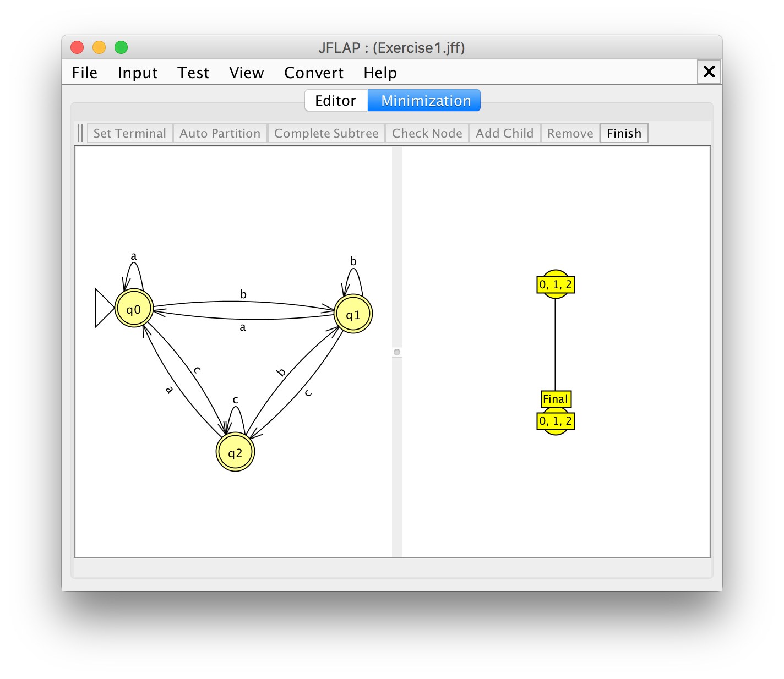

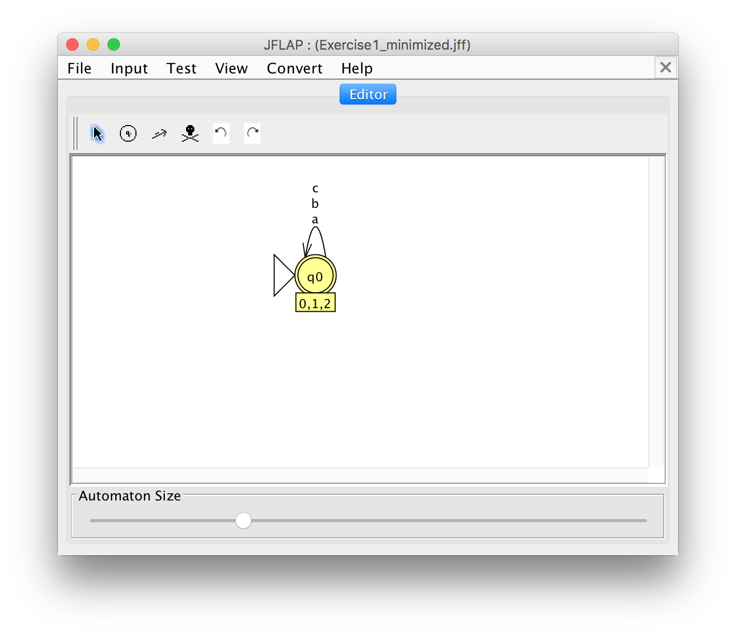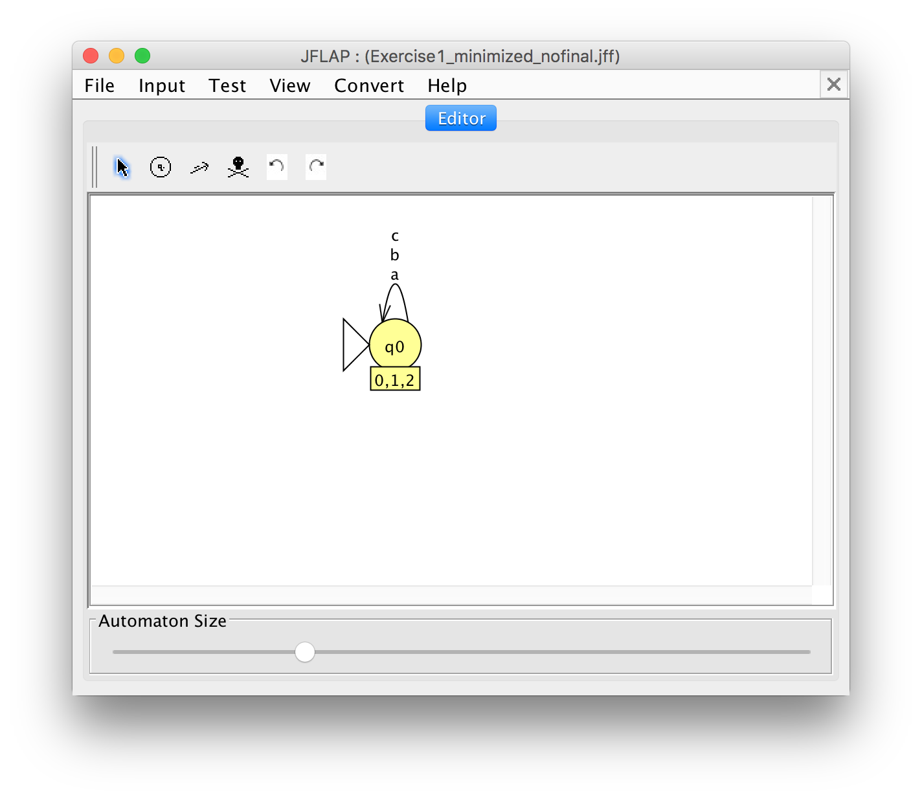

## Questions to Think About

1. What language is accepted by the first minimized DFA? Use formal notation to describe it.

L1 = {ajbkcl | j, k, l >= 0}

1. What language is accepted by the second minimized DFA? Use formal notation to describe it.

L2 = {}

1. What is the relationship between the previous two languages?

L2 ist das Komplement von L1

1. What happens to the language accepted by a DFA if you switch the roles of every state? That is, every final state becomes a nonfinal state, and vice versa.

Es entsteht die Komplementärsprache.

1. Can you predict what happens to the language accepted by an NFA if you switch the roles of every state? Why or why not?

Nein, es entsteht eine komplett neue Art von Sprache.

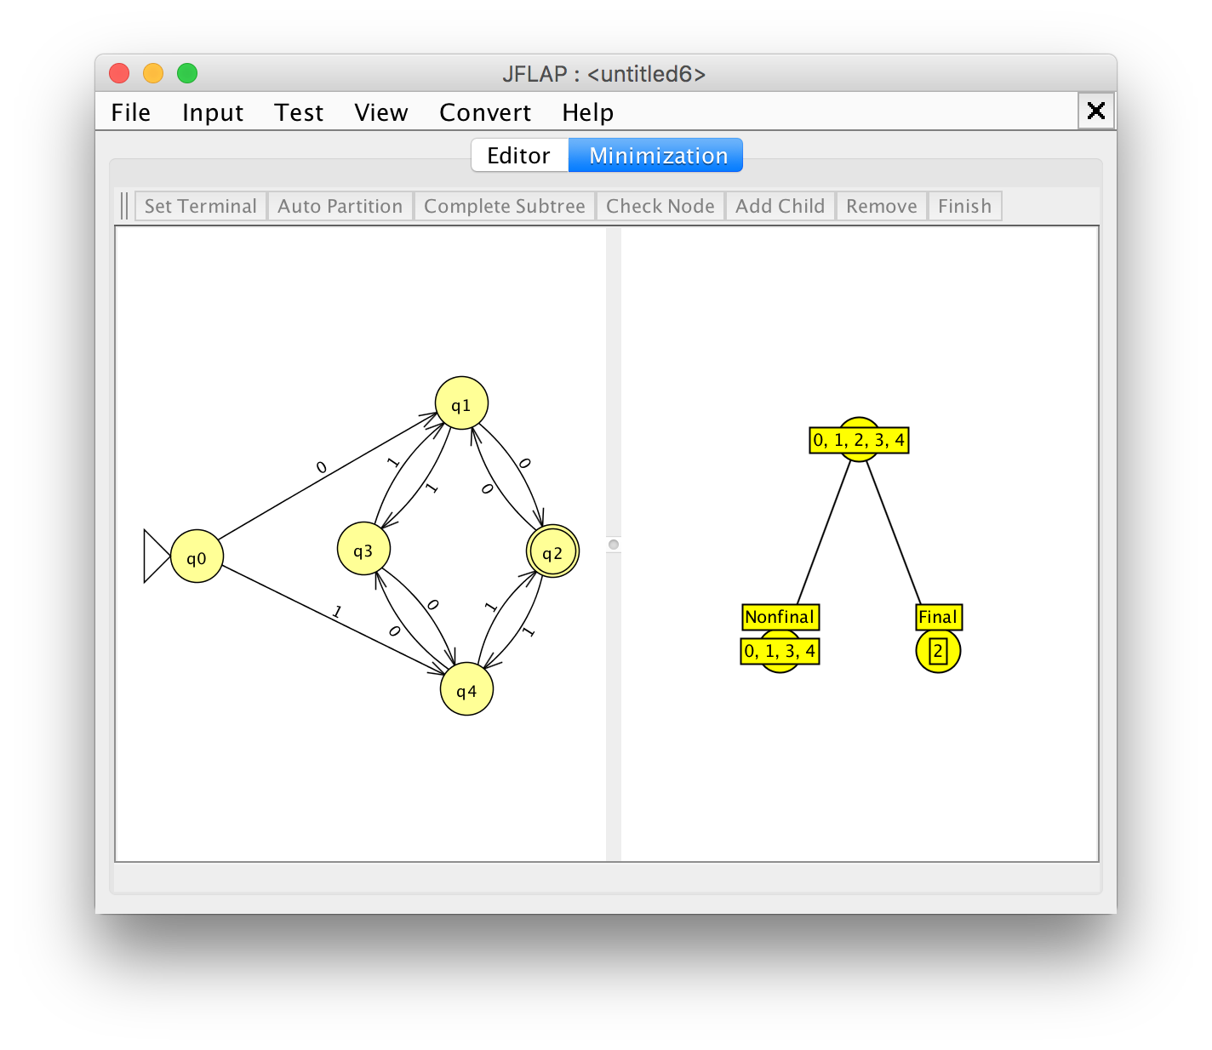

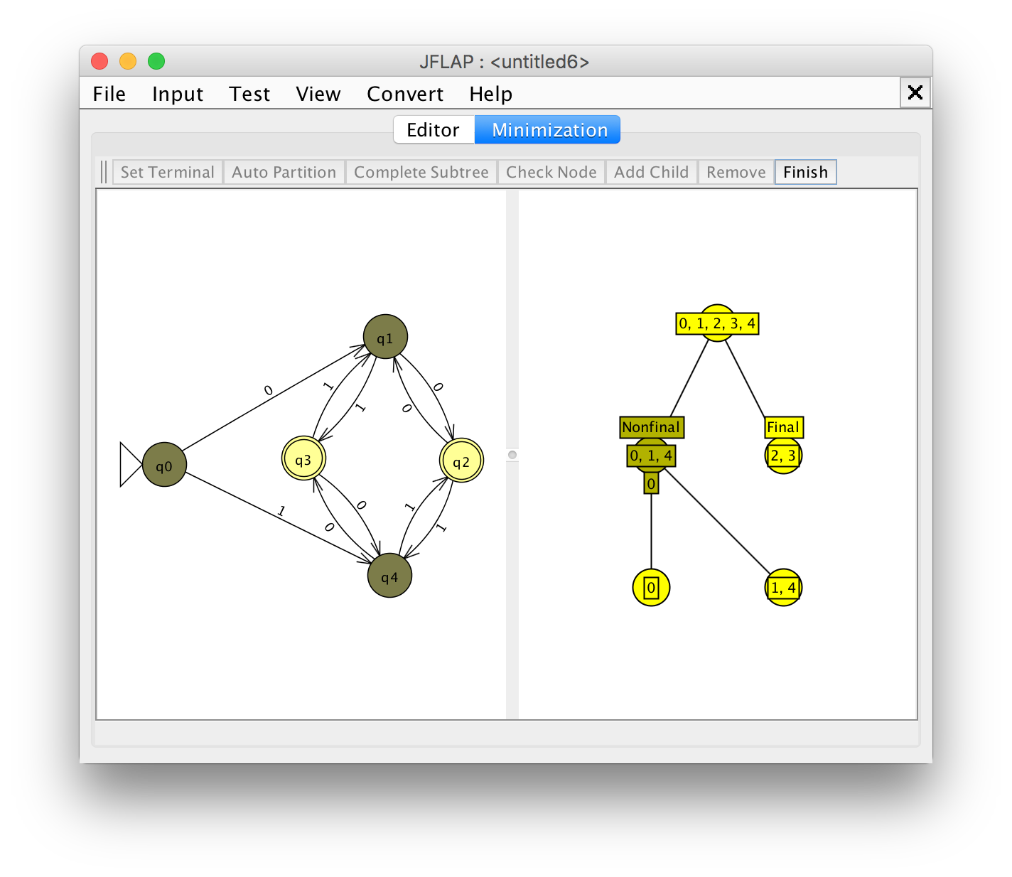

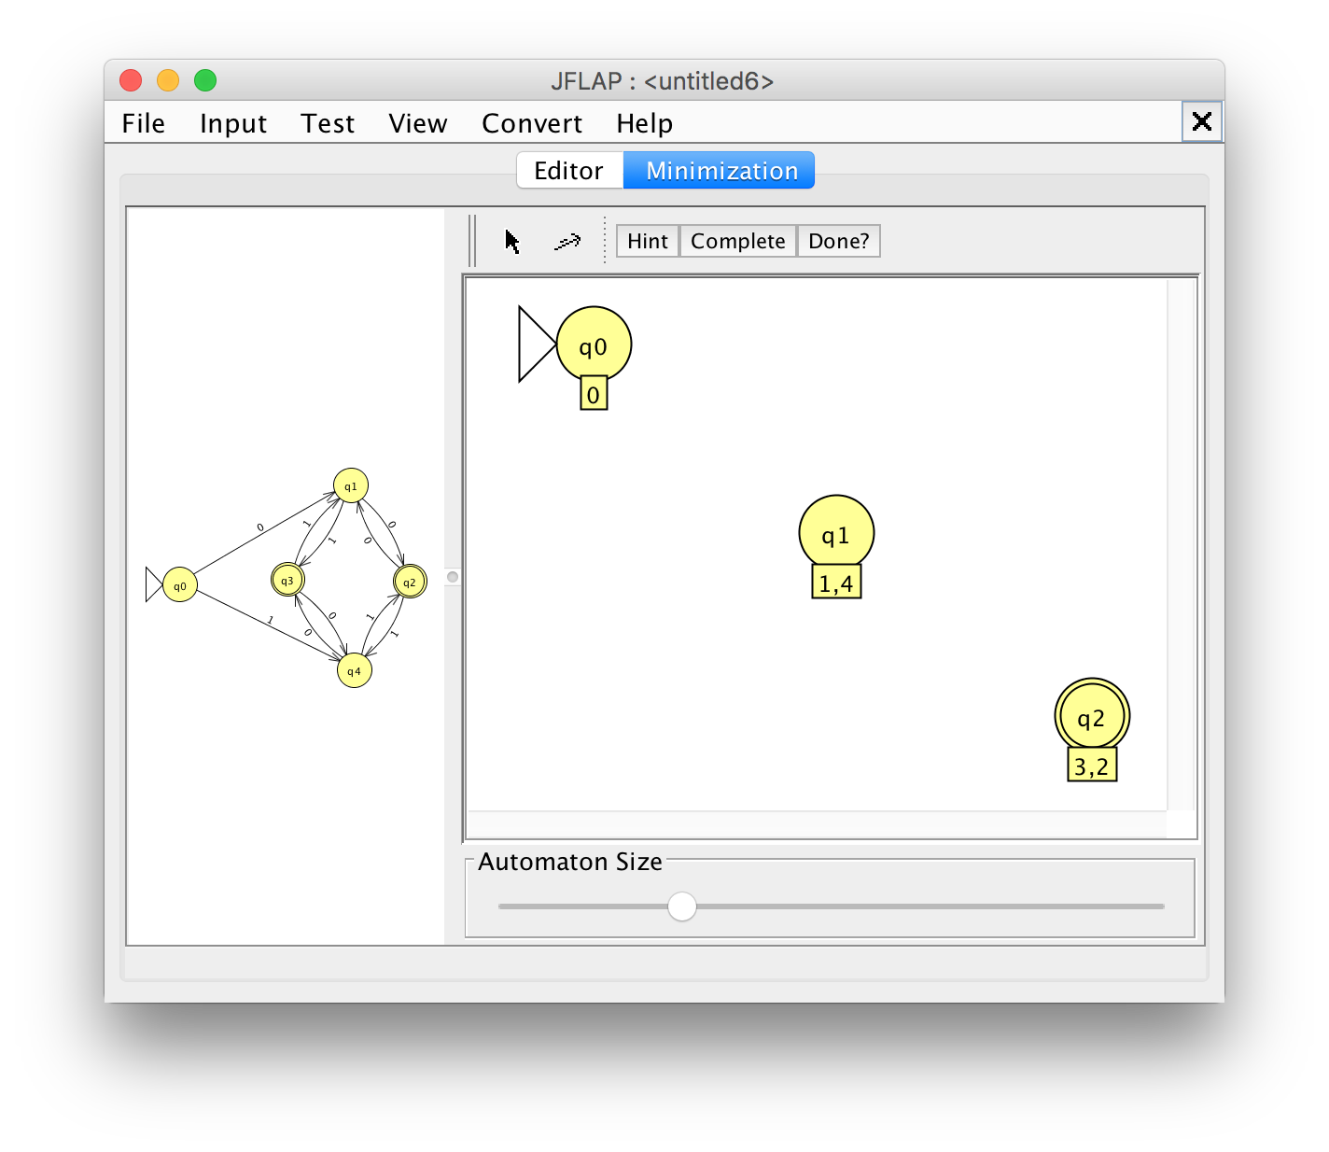

## Questions to Think About

1. Which state should be the start state in the minimized DFA? Why?

q0, da er auch im originalen Automaten der Anfangs-Zustand ist.

1. Which states should be final states in the minimized DFA? Why?

q2, da dieser den Original-Zuständen q2 und q3 entspricht.

1. Can a final state ever be equivalent to a non-final state? Why or why not?

Ja, wenn er dieselben Zeichen akzeptiert.

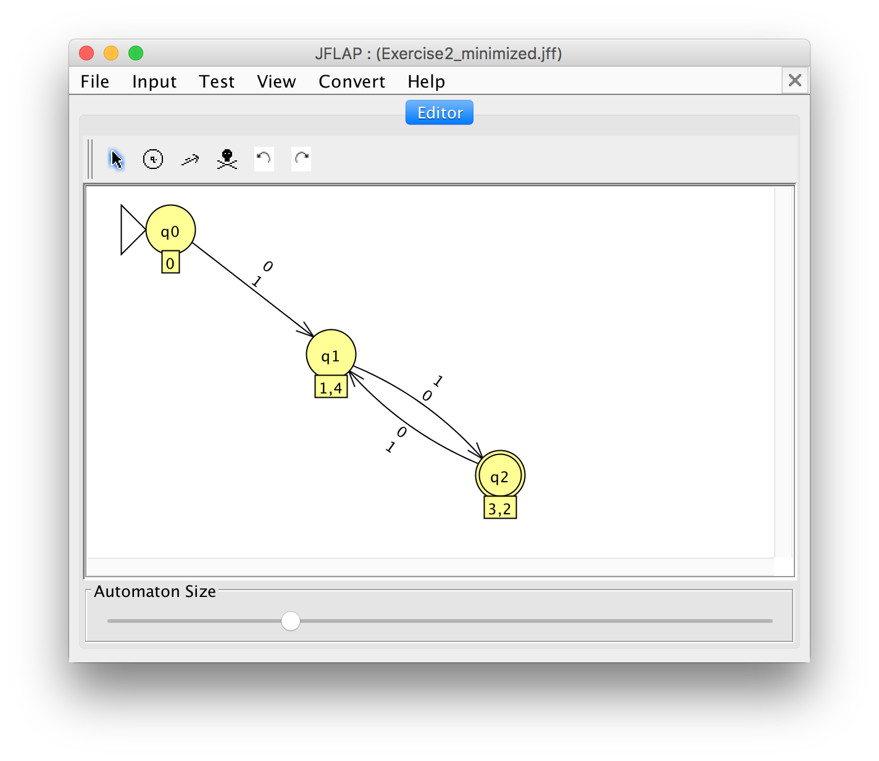

Go back to the original DFA, and modify it so that it accepts the empty string because the empty string has 0 (an even number) occurrences of 0's and 0 occurences of 1's.

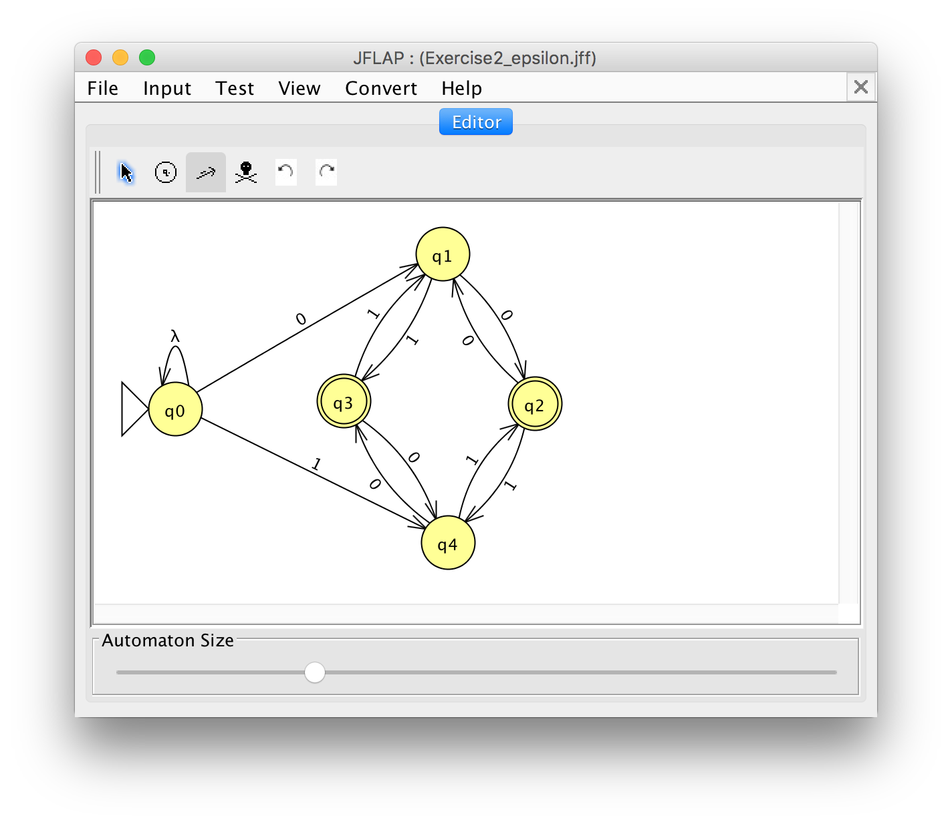



## Questions to Think About

1. How many states are in the minimum-state DFA accepting all strings over alphabet Σ?

2 (q1, q2)

1. How many states are in the minimum-state DFA accepting no strings over alphabet Σ?

0

1. How many states are in the minimum-state DFA accepting a single string of length n?

1 (q0)

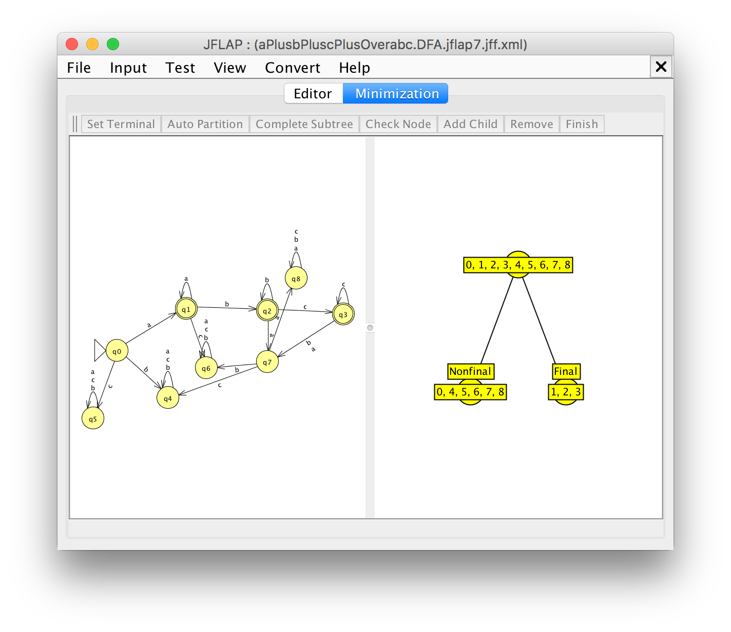

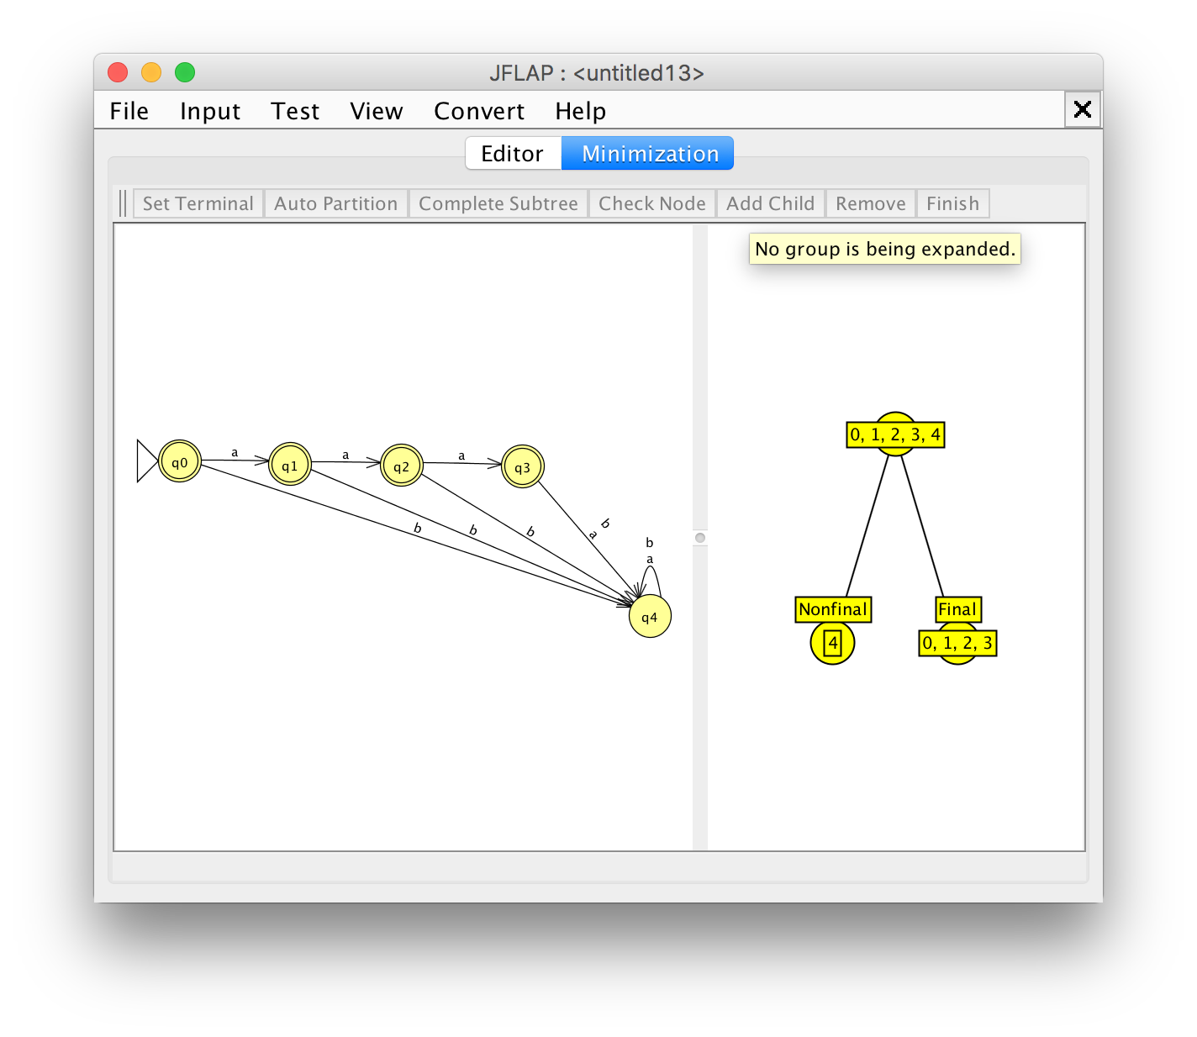

# Exercise 1

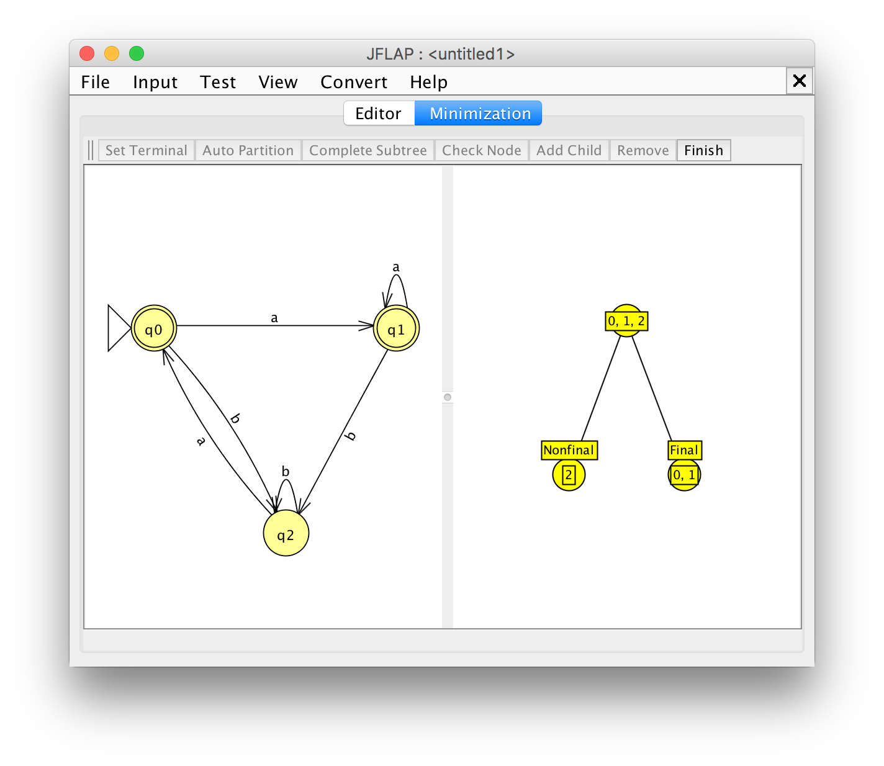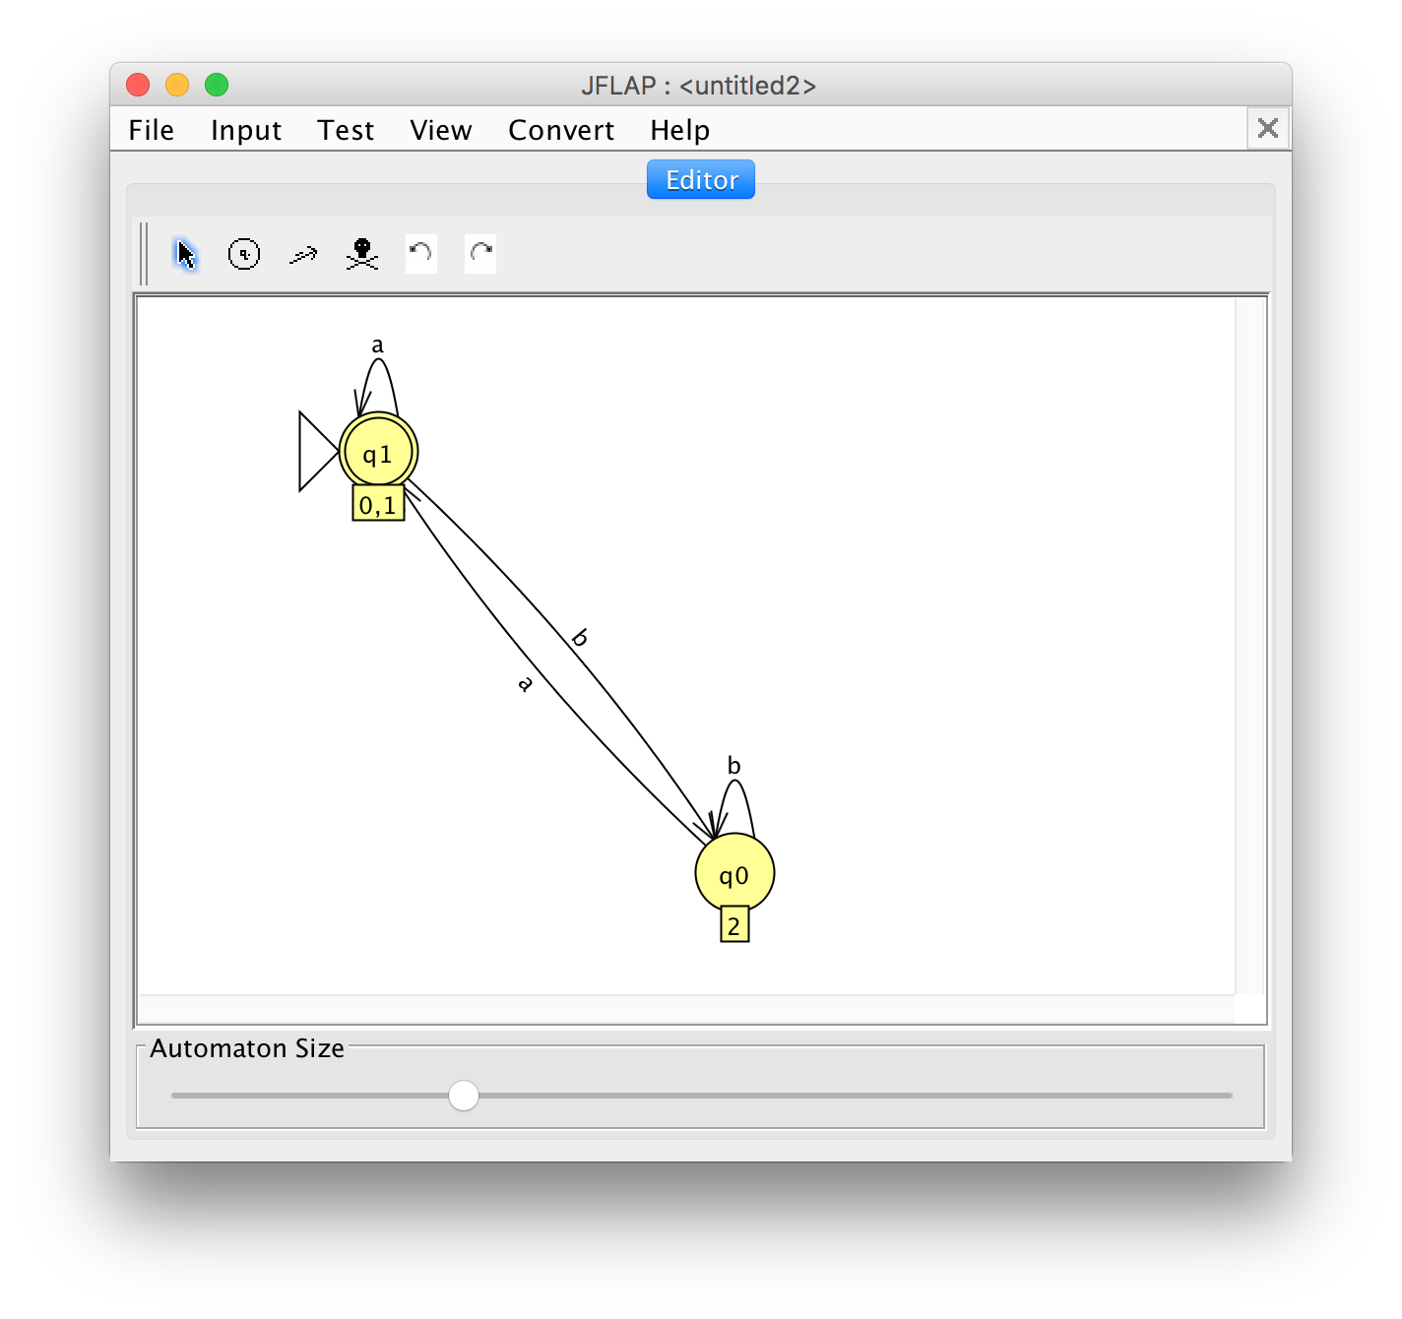

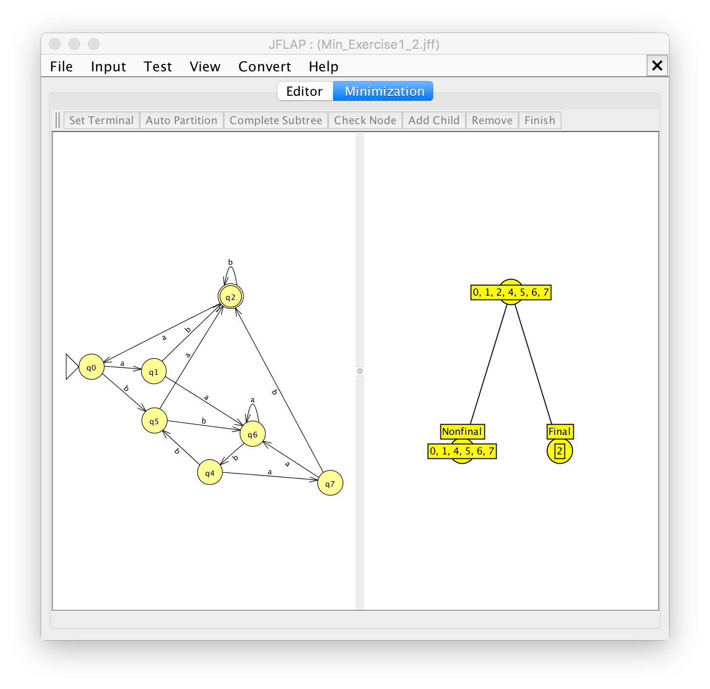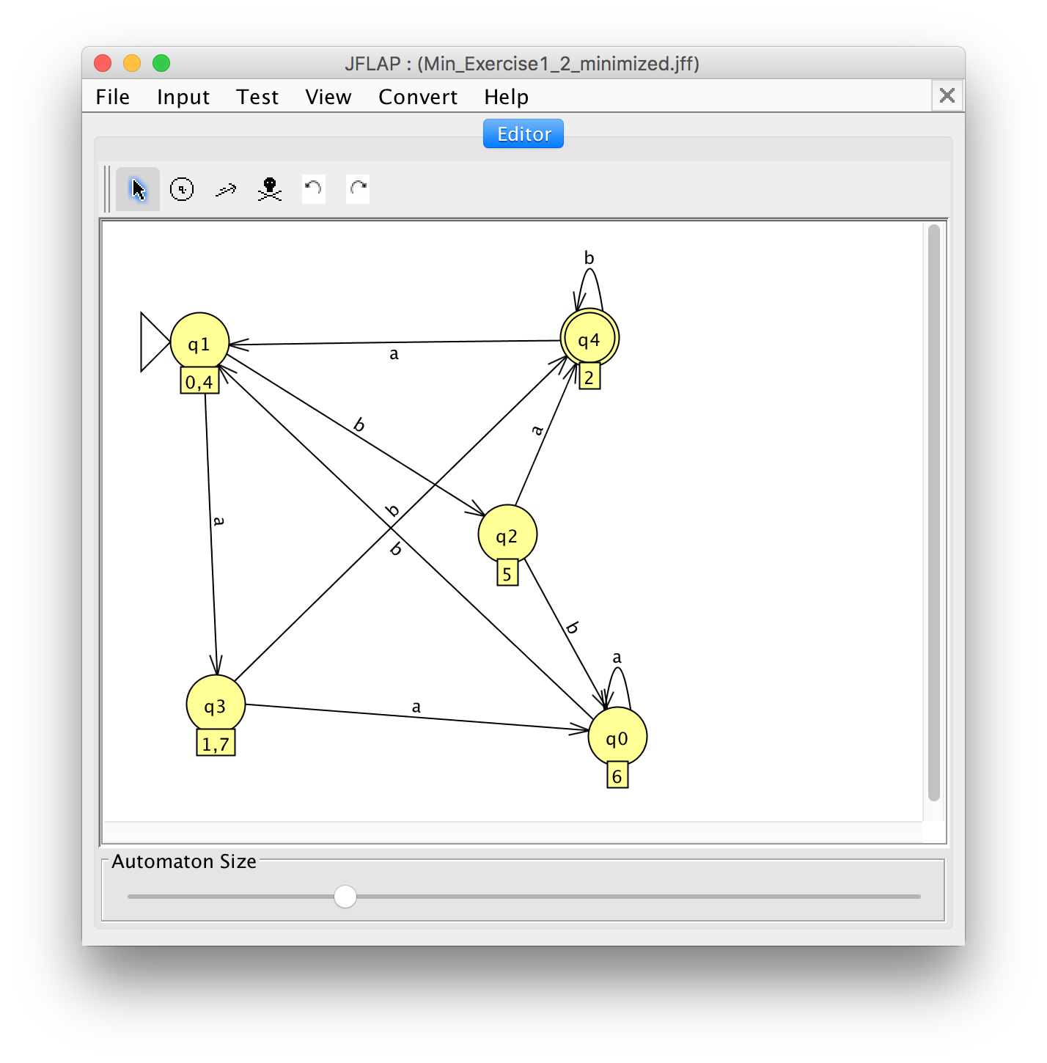

# Exercise 2

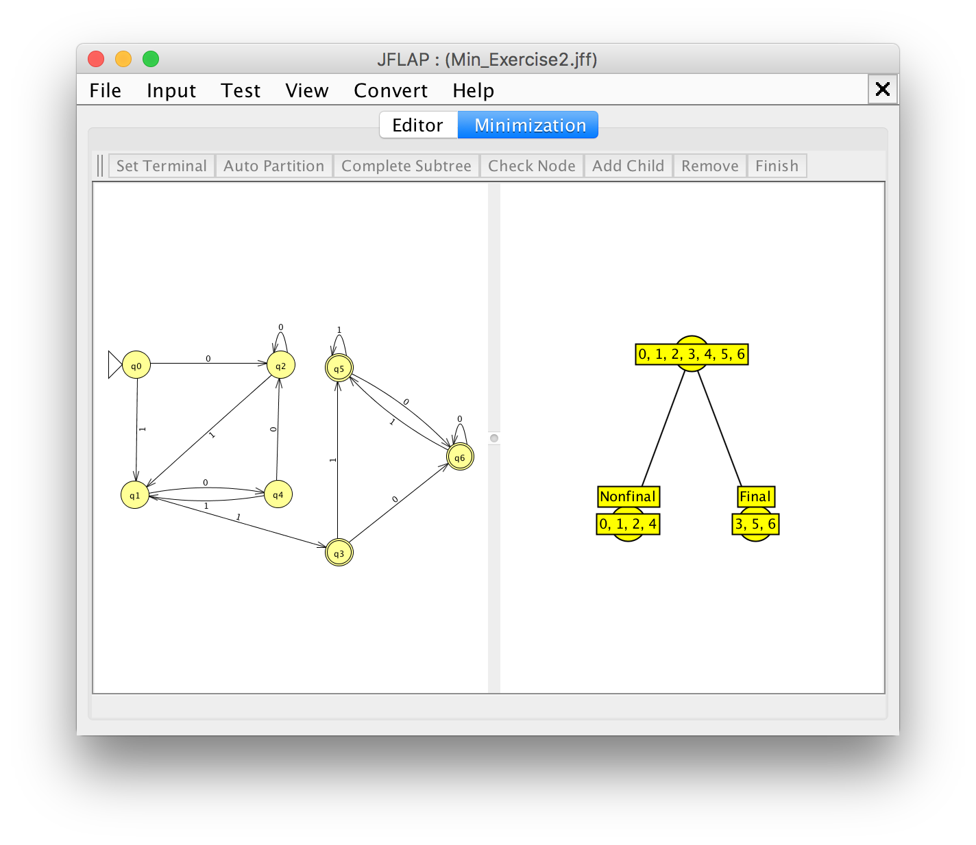

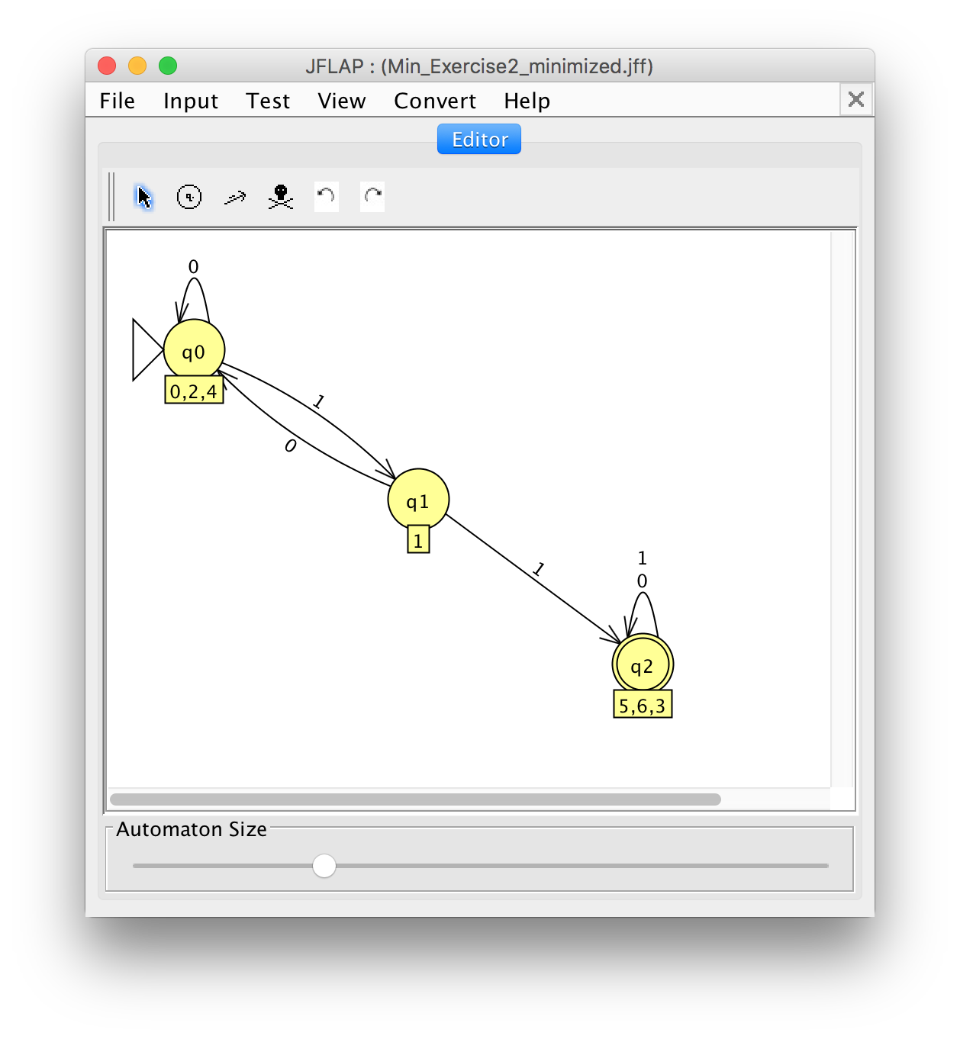

# Exercise 3

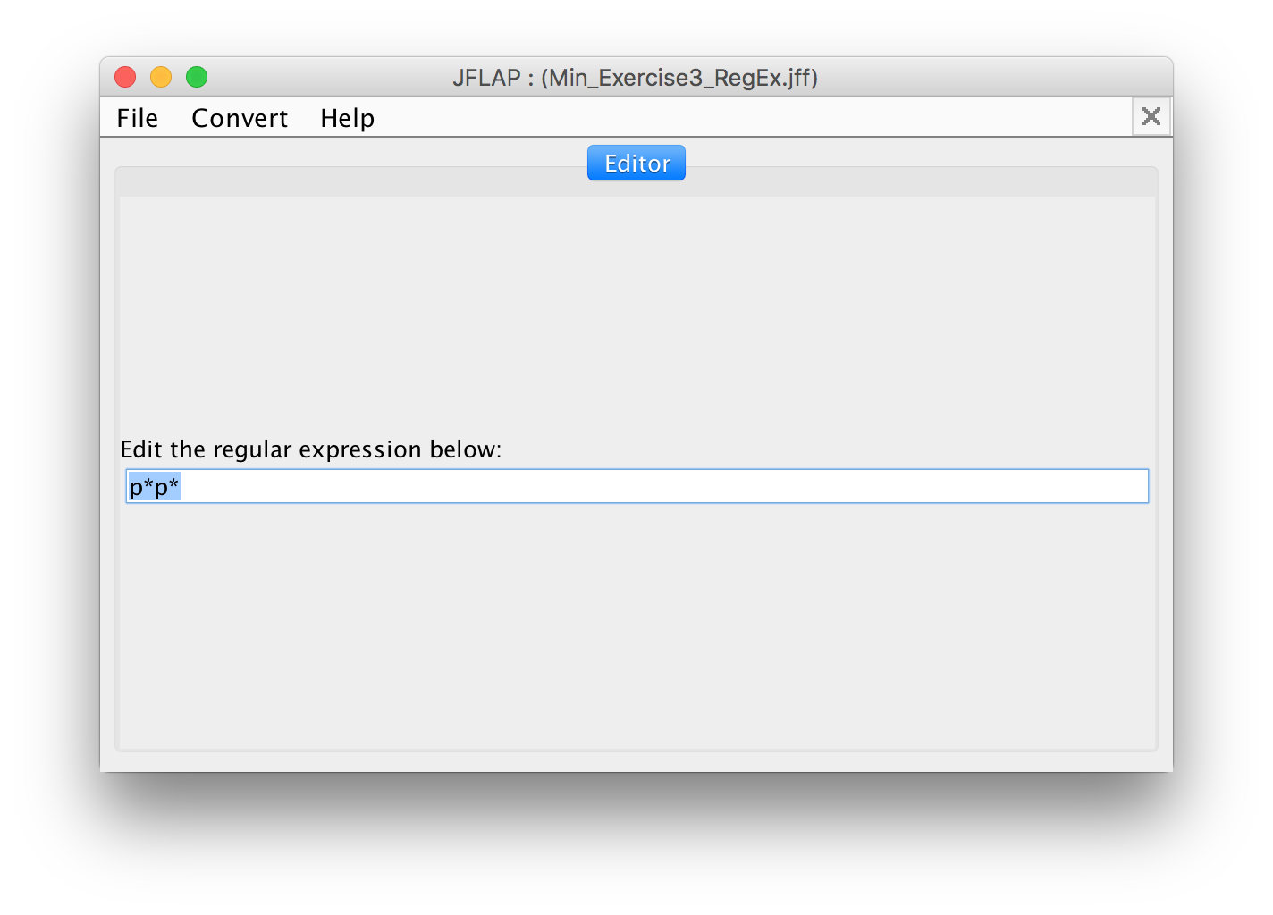

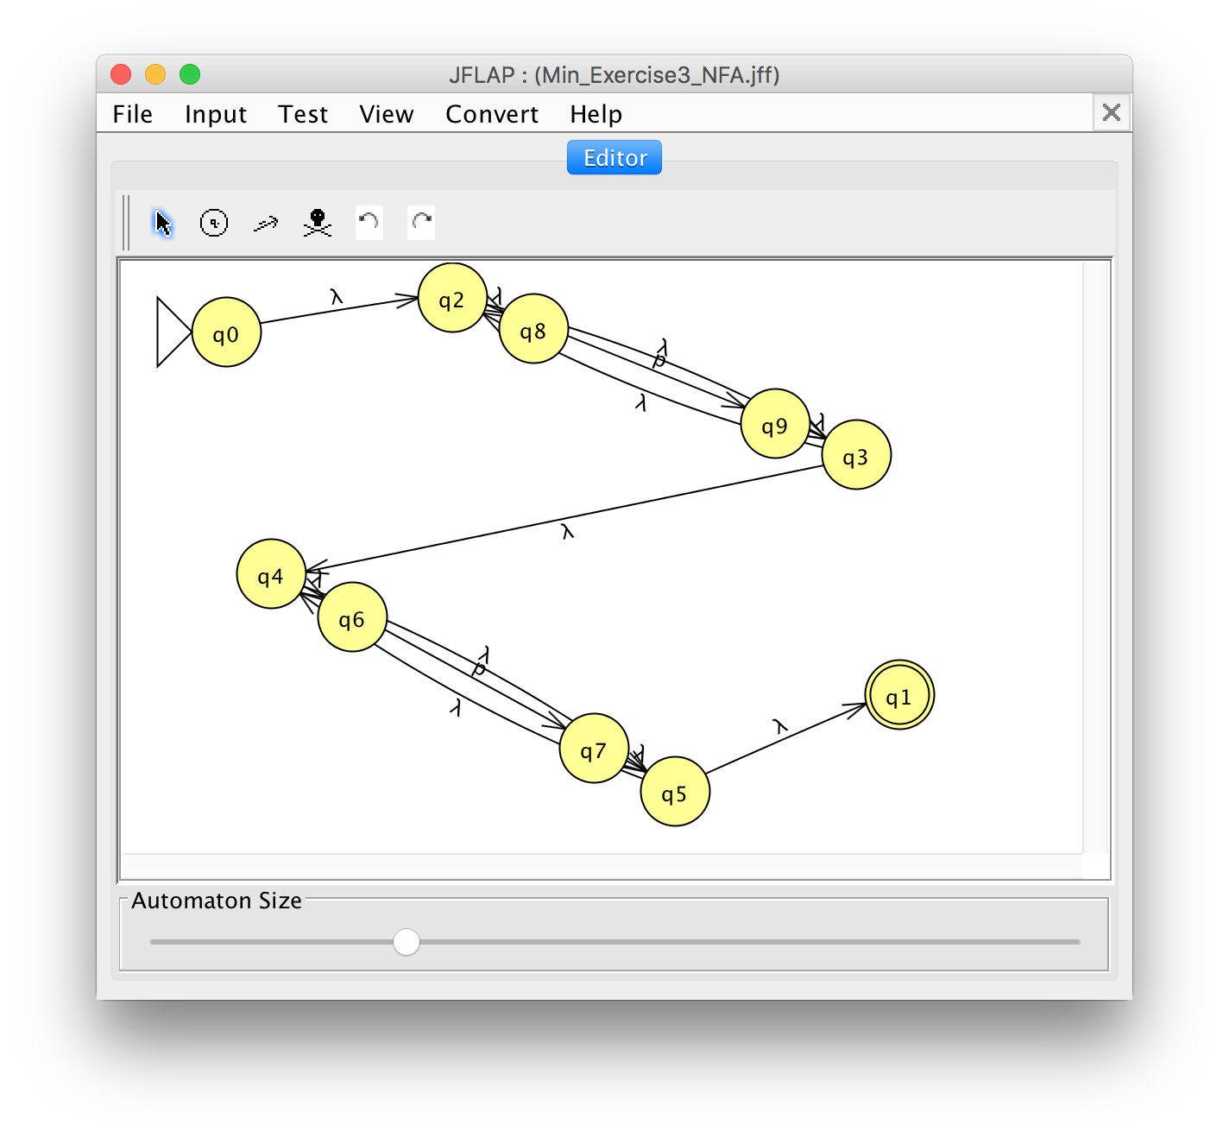

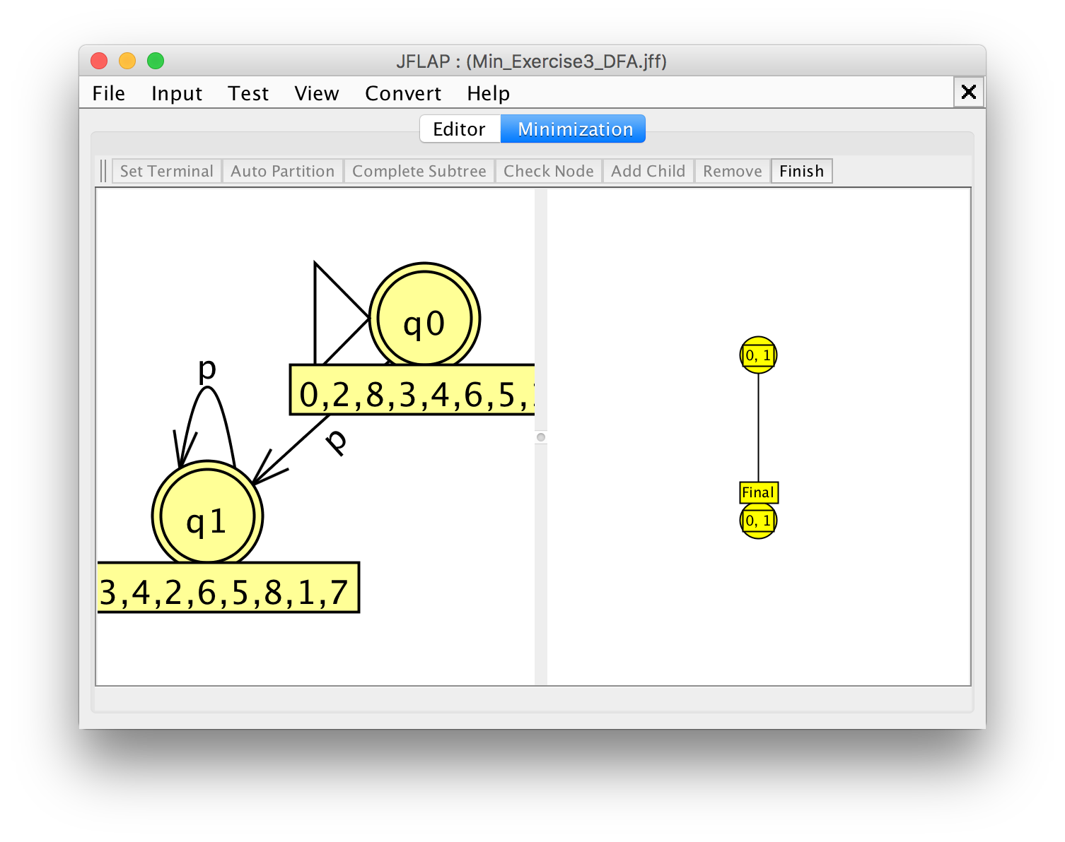

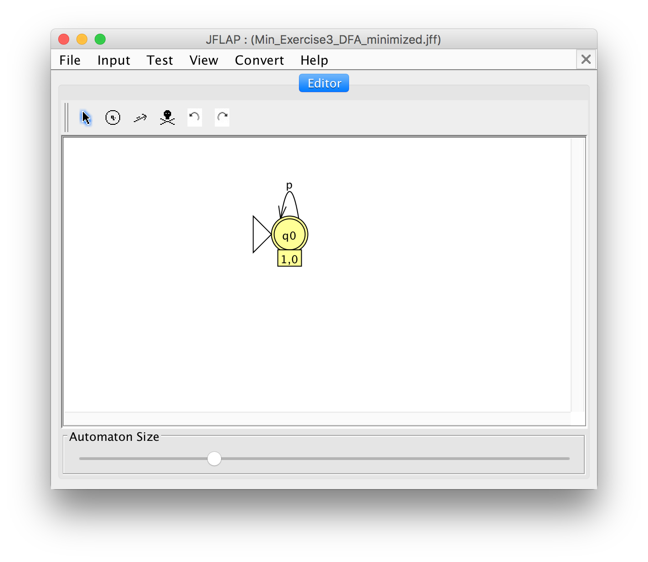

DFA to Regular Grammar Conversion

# Module

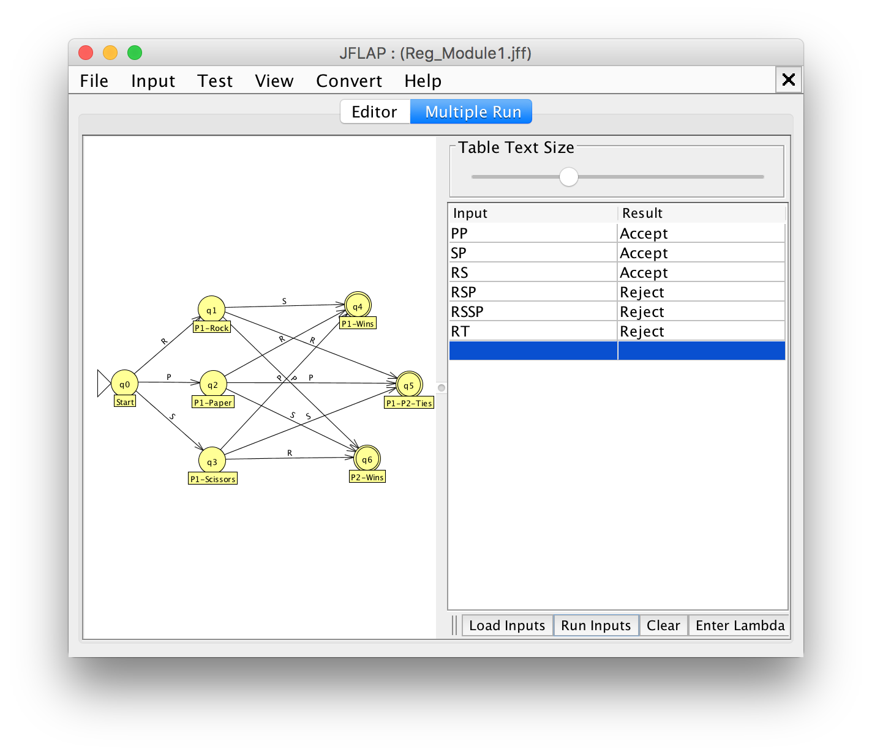

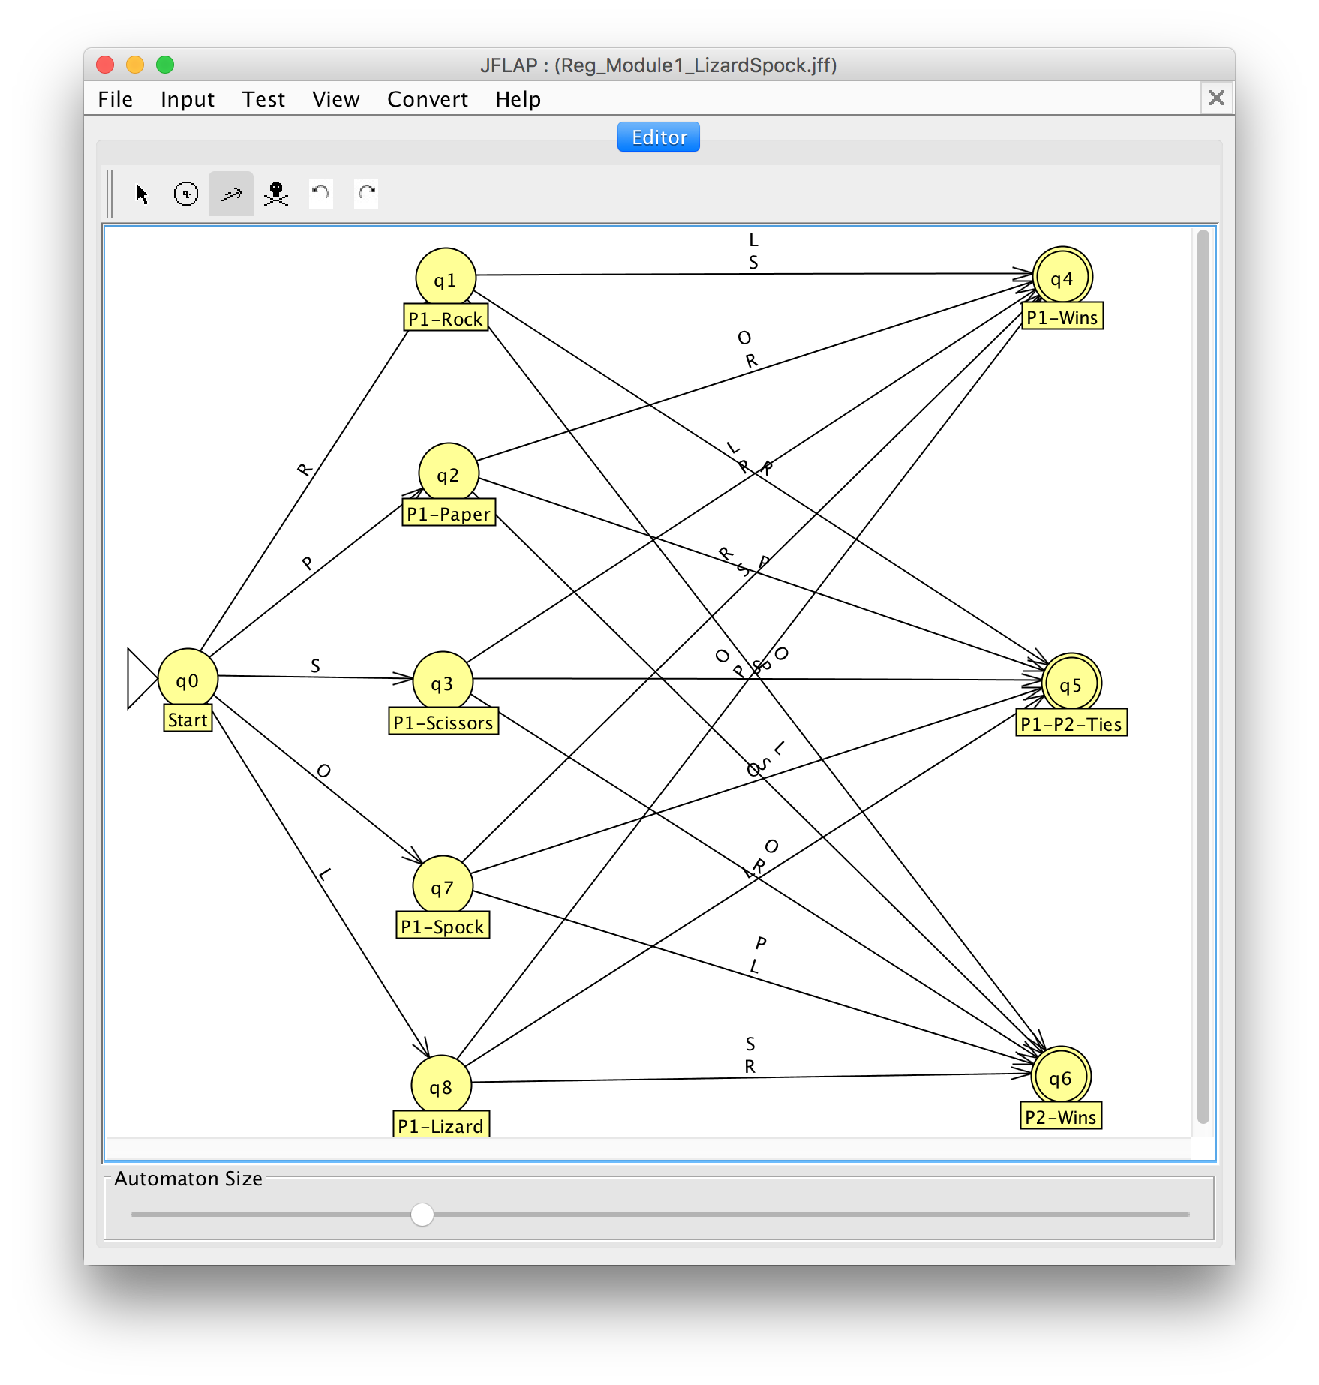

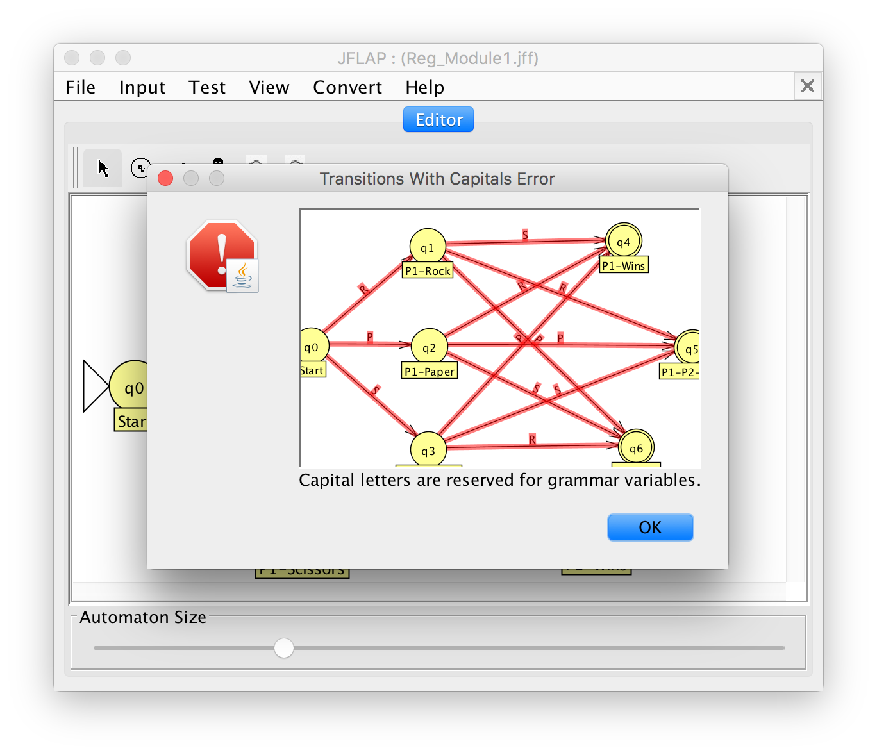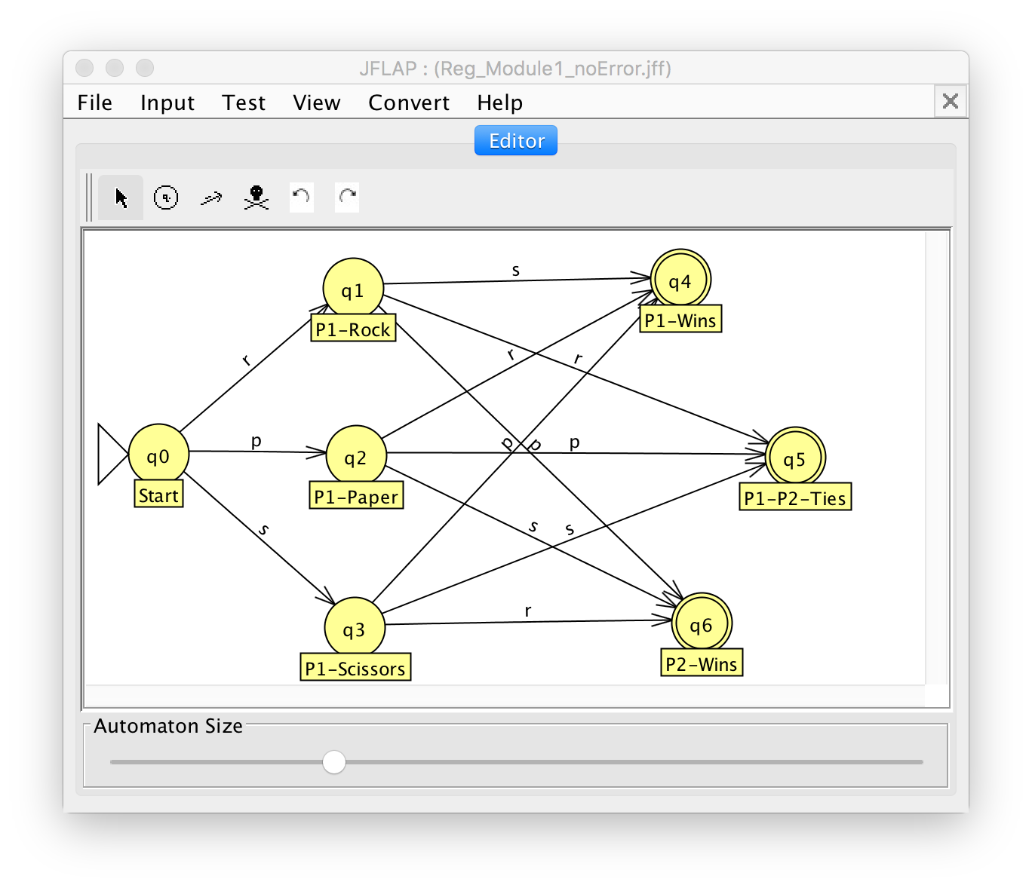

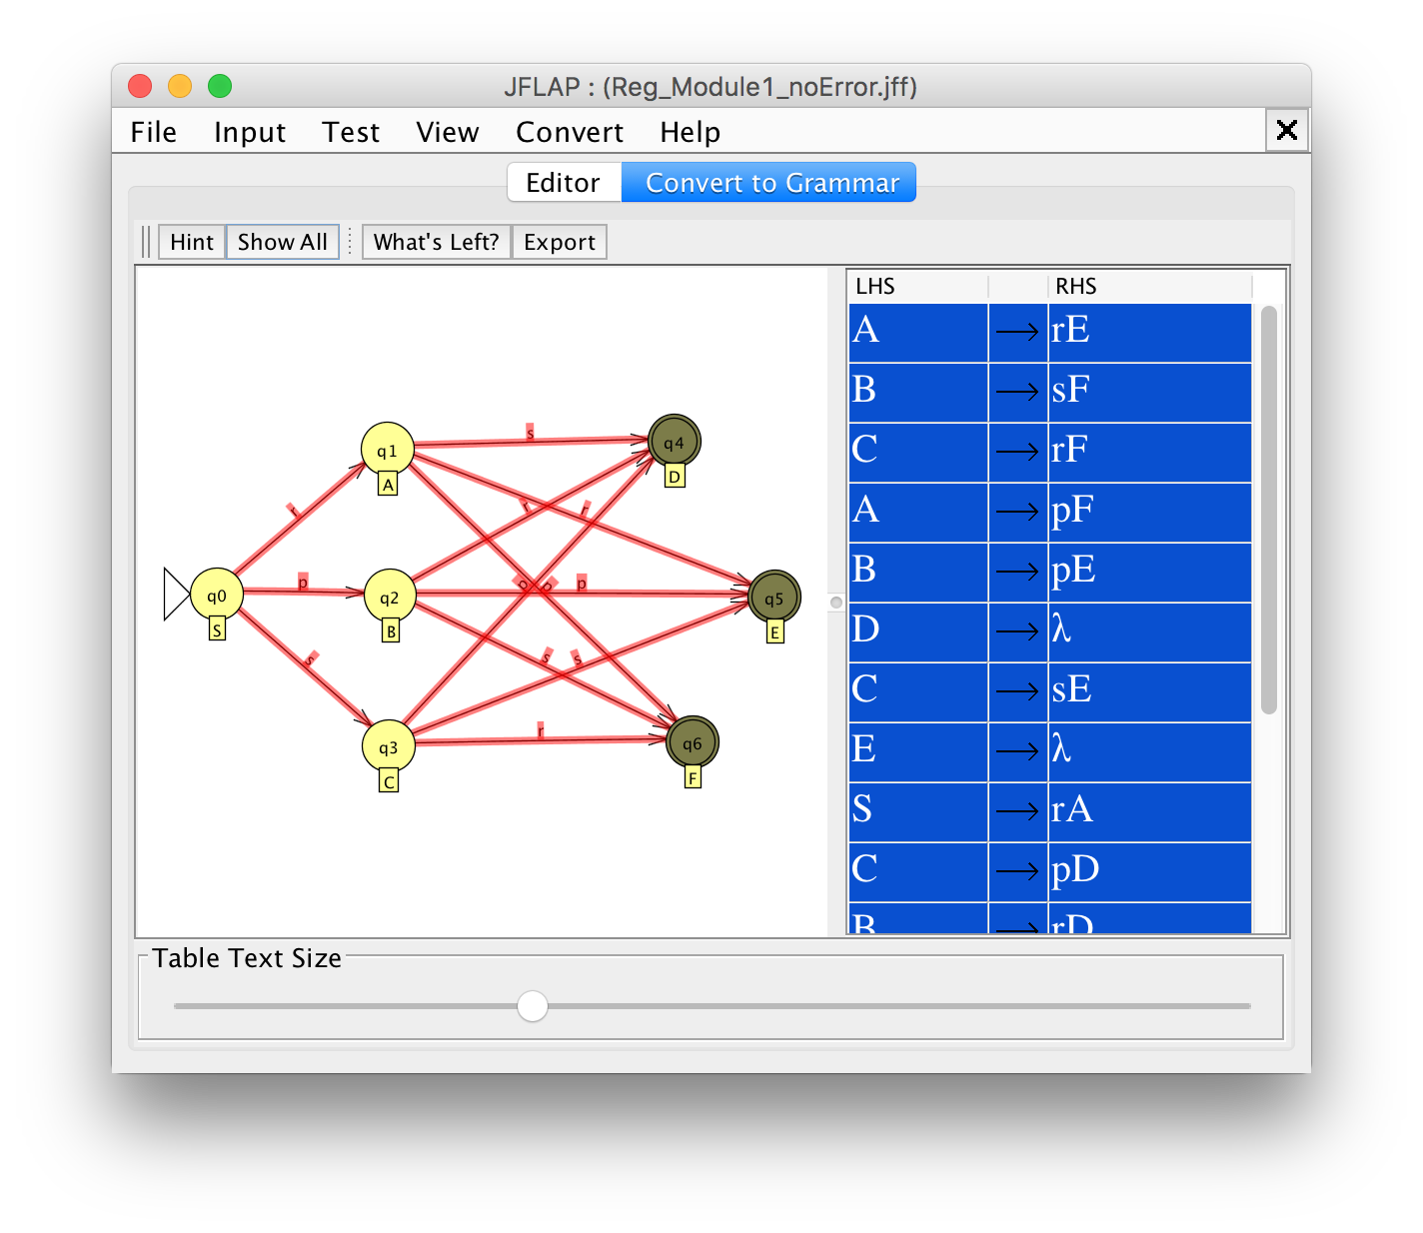

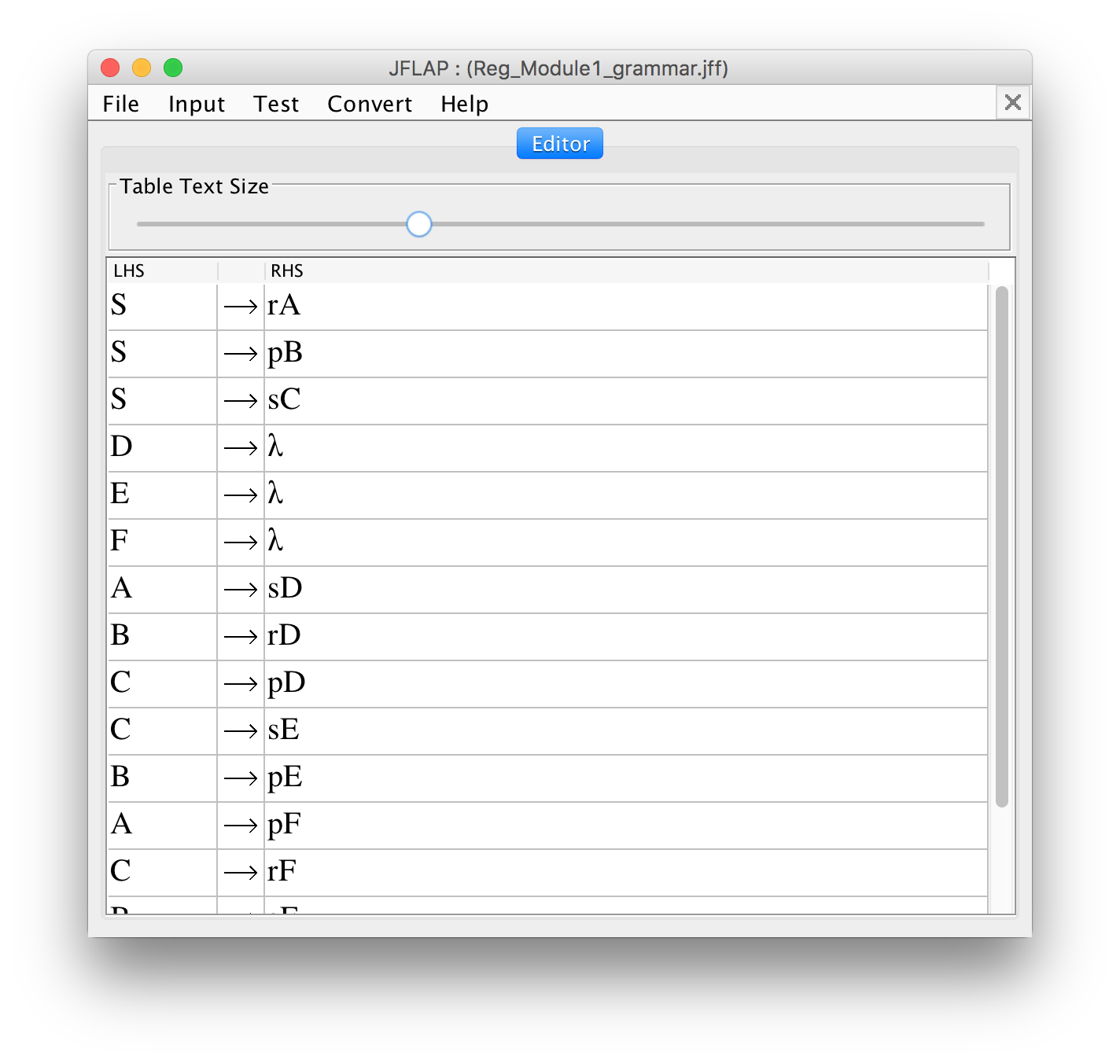

# Exercise 1

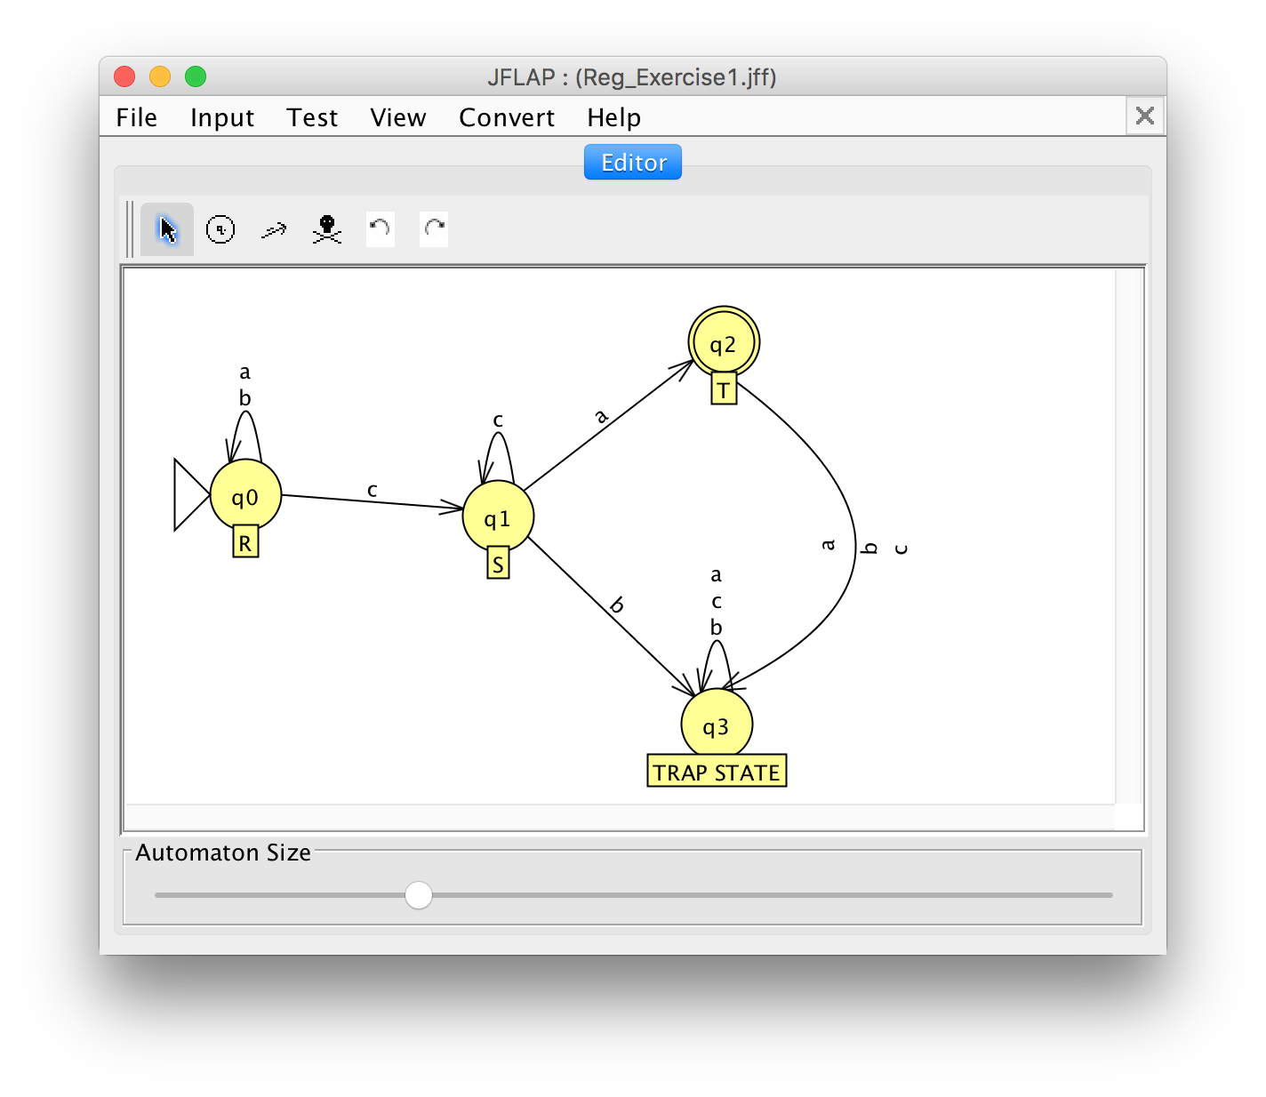

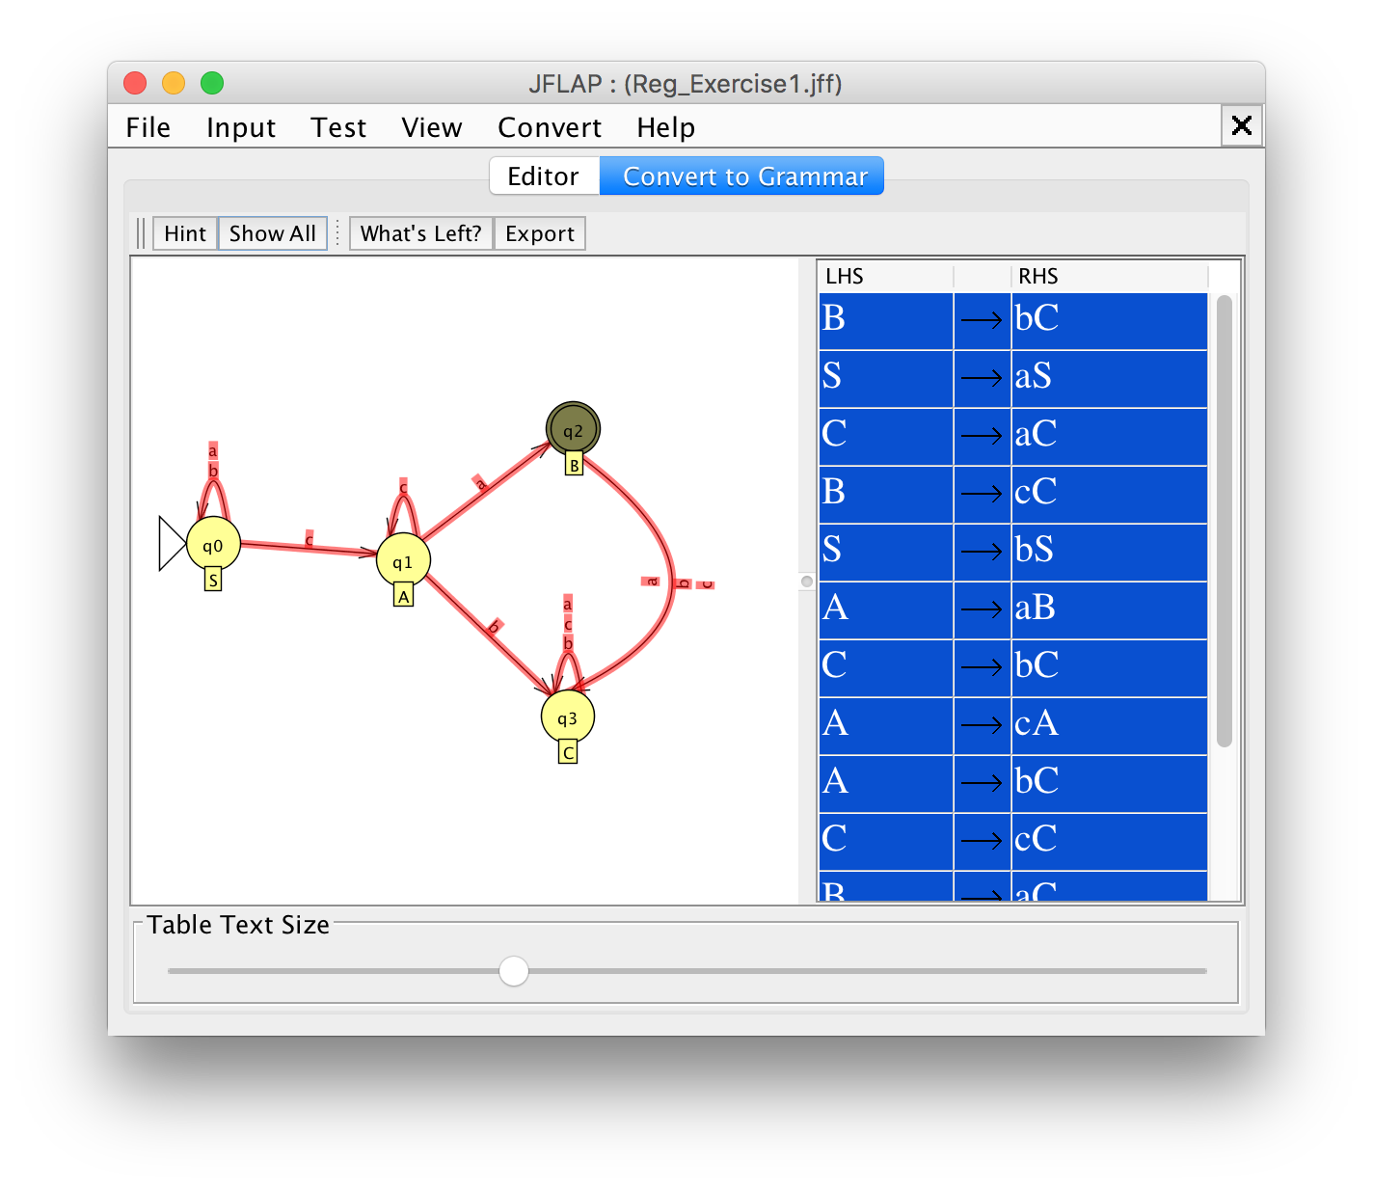

# Exercise 2

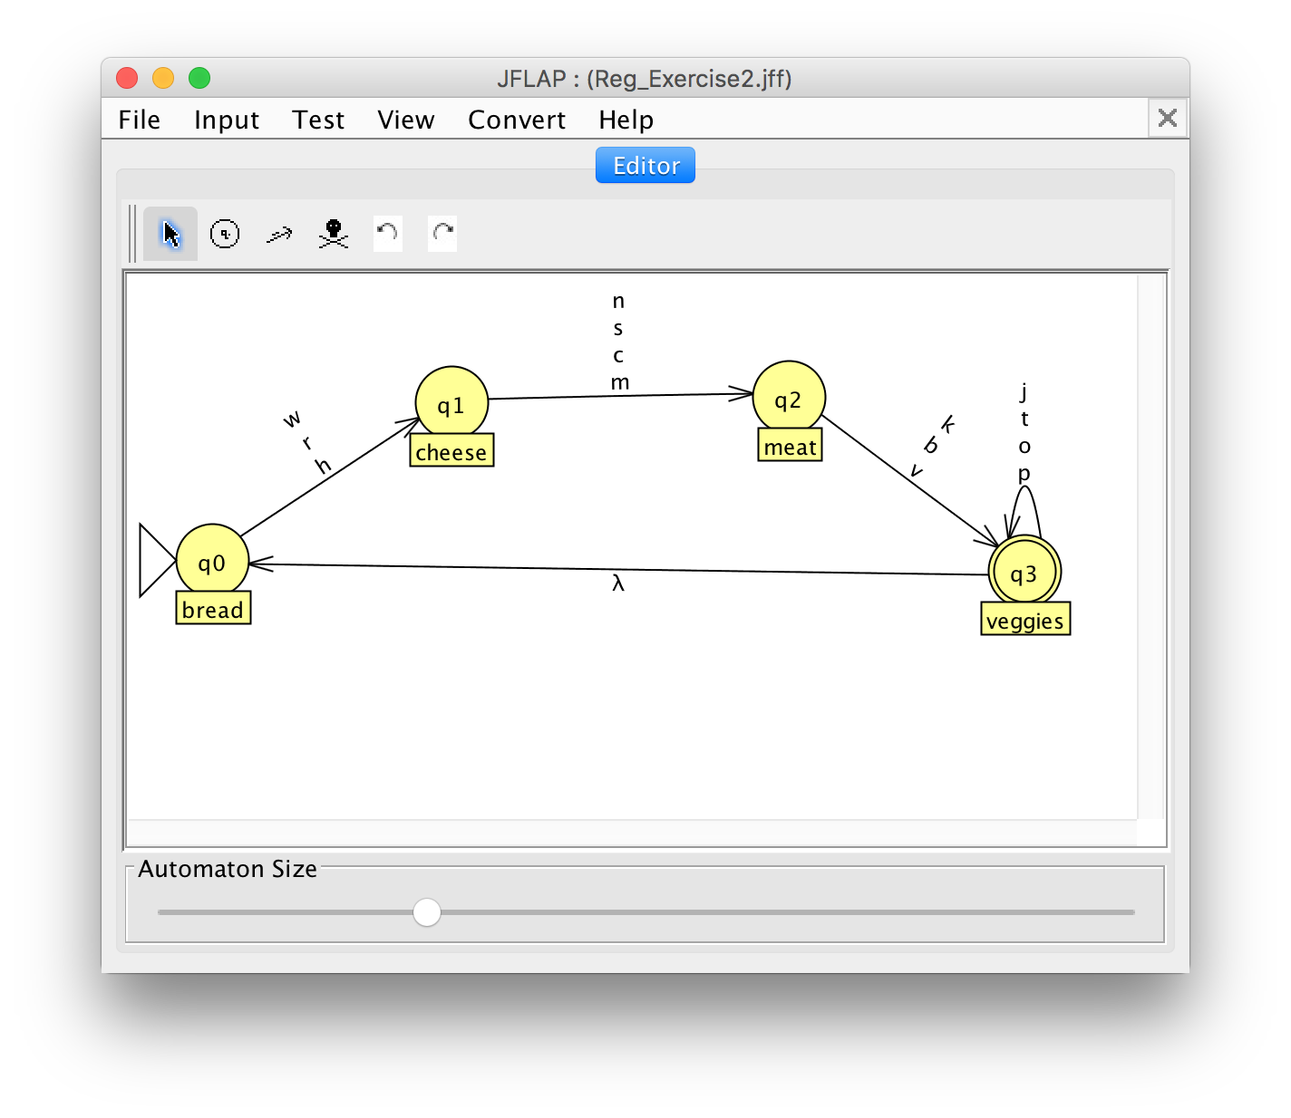

## Questions to Think About

1. What is the length of the shortest string accepted by the DFA?

3

1. How many such shortest strings are there? Why? (Hint: Think back to your discrete mathematics course.)

3*4*3 = 36

1. What is the order in which components of a sandwich must be chosen? Why?

Bread – cheese – meat – veggies, weil keine anderen Übergänge existieren

1. Can a valid string end with a comma? Why or why not?

Nein, ist nicht im Alphabet.

1. How many variables will the corresponding regular grammar have? Why?

14 – Anzahl Zeichen im Alphabet

1. How many production rules will the corresponding regular grammar have? Why?

4 - Gruppen

1. How many lambda rules will the corresponding regular grammar have? Why. Remember that a **lambda rule** is a rule of the form A → λ, where A is a variable.

1 – nächste Bestellung

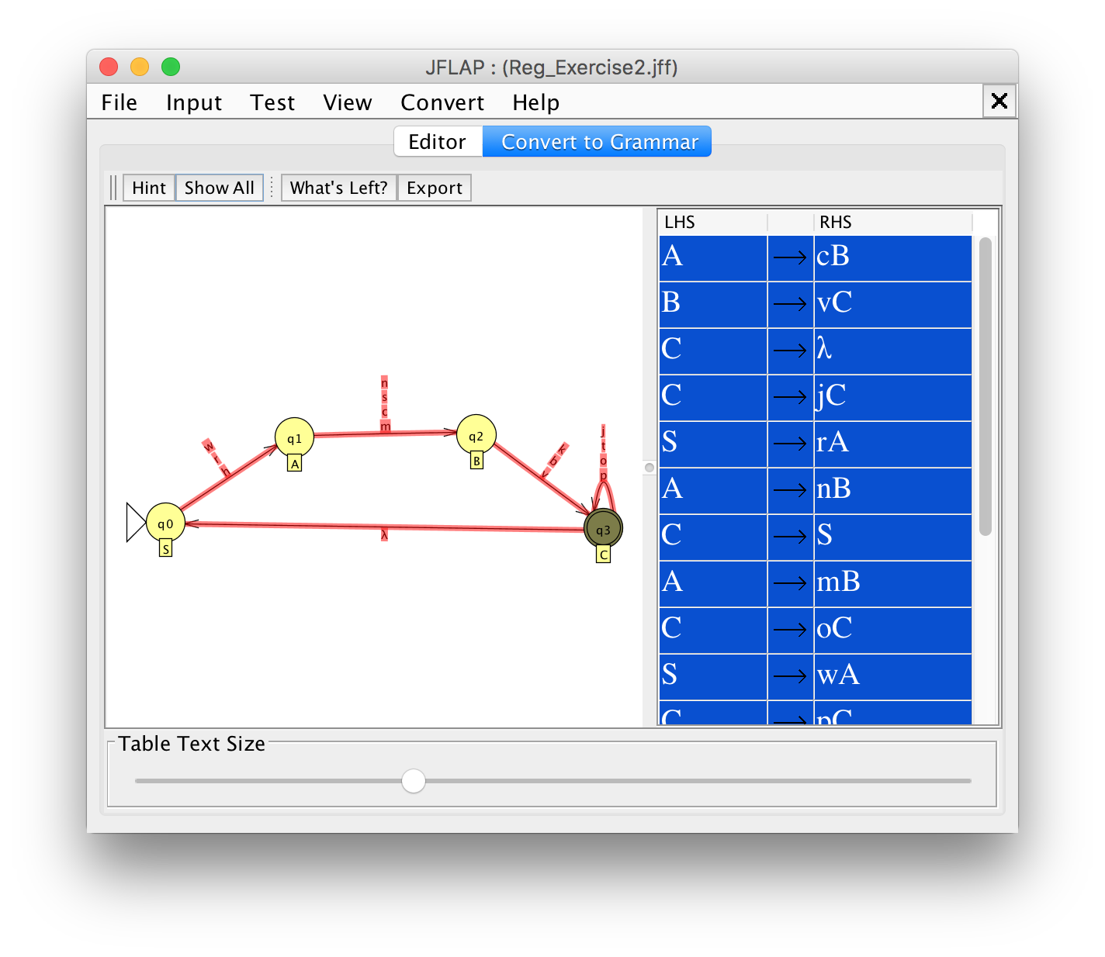

## Questions to Think About

1. Does this grammar have recursive production rules? Why or why not?

Ja – weil der letzte Schritt wieder den ersten ruft (iterativ?).

1. If it does have recursive production rules, how is the recursion stopped?

Wenn nach den „veggies“ nichts mehr kommt.

1. What can you say about the number of strings in a language with a grammar with no recursive production rules?

Die Anzahl Wörter ist begrenzt.

# Exercise 3

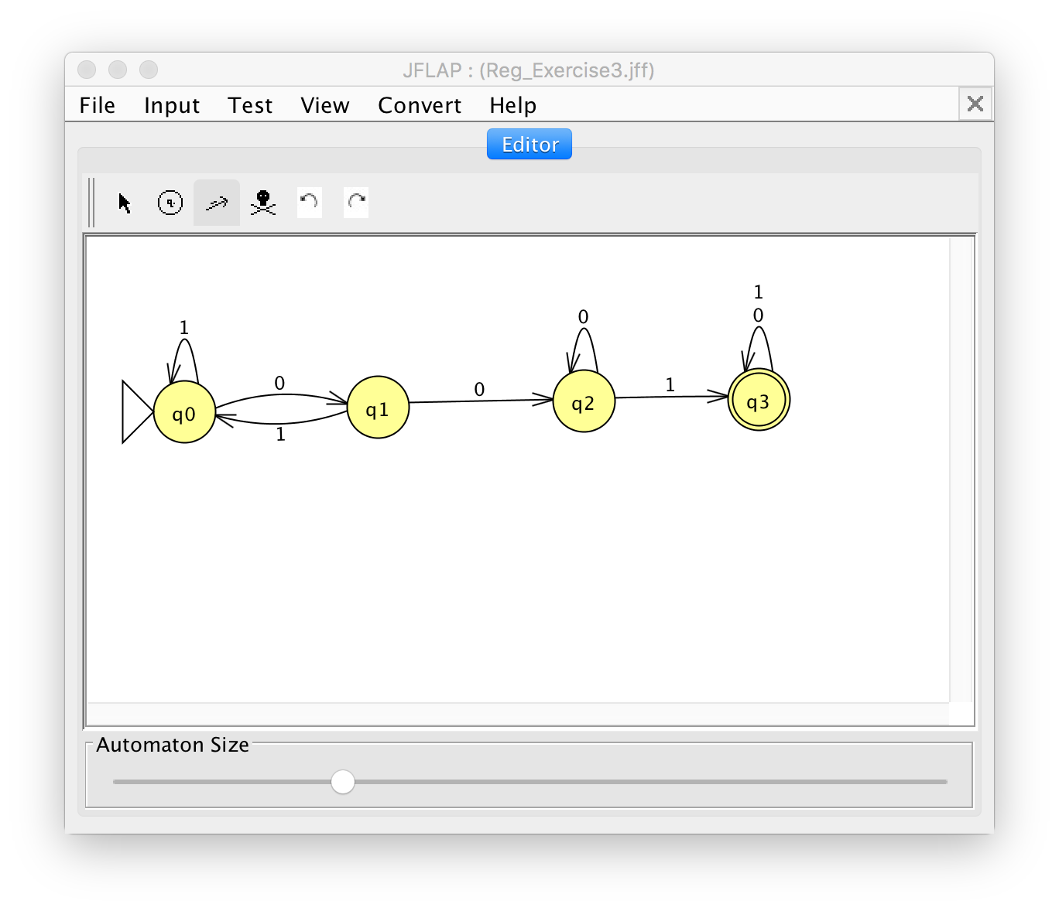

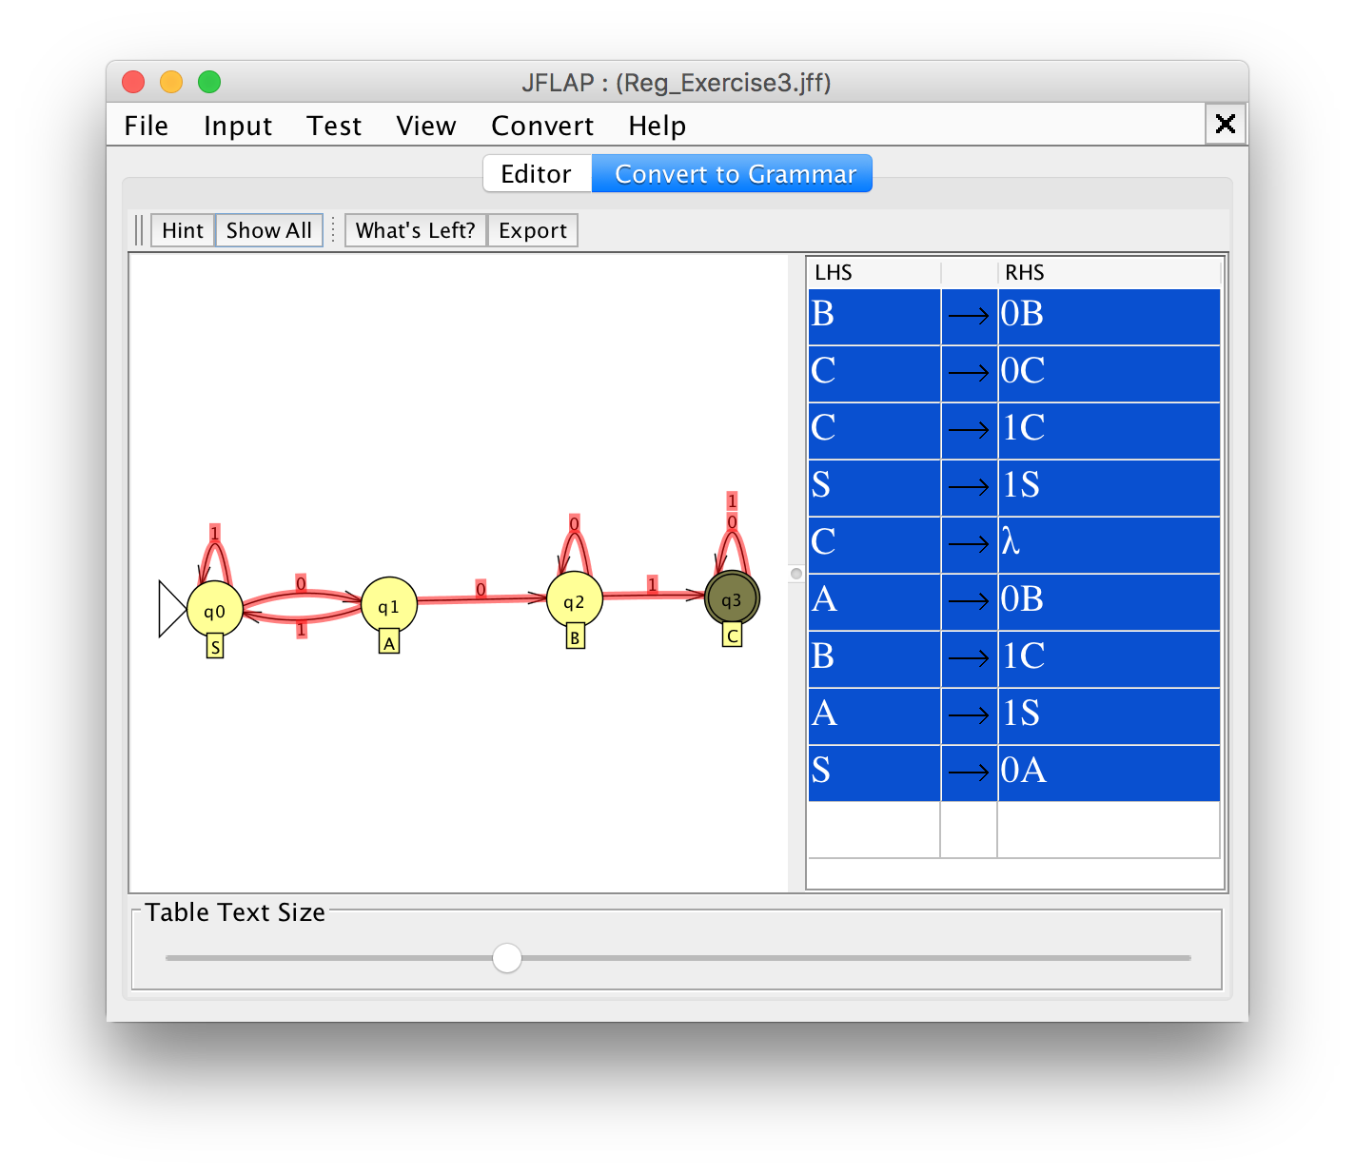

# Exercise 4

